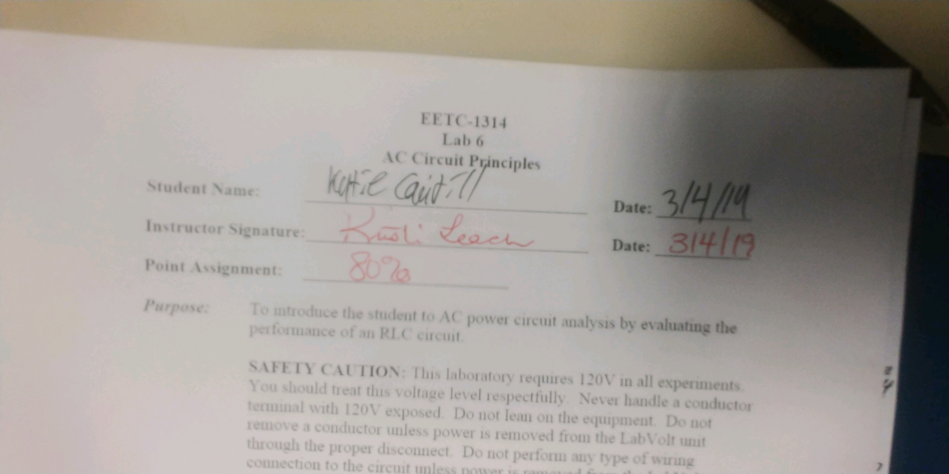
Student Name: _________________________________ Date: ___________

Instructor Signature:_________________________________ Date: ___________

Point Assignment: ________________________

Purpose: To introduce the student to AC power circuit analysis by evaluating the performance of an RLC circuit.

SAFETY CAUTION: This laboratory requires 120V in all experiments. You should treat this voltage level respectfully. Never handle a conductor terminal with 120V exposed. Do not lean on the equipment. Do not remove a conductor unless power is removed from the LabVolt unit through the proper disconnect. Do not perform any type of wiring connection to the circuit unless power is removed from the LabVolt unit. Always verify that power is off by observation and measurement. Students must always have supervision from an experienced instructor or laboratory technician when working with the LabVolt equipment.

Background: Fundamental circuit analysis is the same whether working with DC or AC circuits. The main difference between the circuit principles is the results depend on the phase relationship of the circuit elements. Capacitors and inductors behave differently in AC circuits than DC, so the analysis requires the use of phasor analysis to properly analyze the circuit. The same fundamental laws of series circuits and parallel circuits continue to hold for the circuit. Each of these principles will be explored for the AC circuit.

Procedure: 1. For the AC series circuit shown, compute the total impedance,
Current through each load element, and the voltage across each circuit element (600Ω and 1.6H).

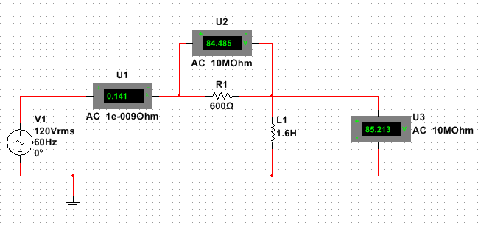

2. Using LabVolt equipment, build the series circuit shown and measure the current and voltage across each circuit element (source, 600Ω and 1.6H). Show that Kirchhoff’s Voltage Law holds.

 | Calculated |  | Measured
Circuit Element | Voltage | Current | Voltage | Current
Voltqge Source | 120<0V | 414<-45.1 mA | 120 V | 130 mA
Resistor, 600Ω | 84.6<  -45.1V | 414<-45.1 mA | 80 V | 130 mA
Inductor, 1.6H | 85<44.9V | 414<-45.1 mA | 82 V | 130 mA

3. For the AC parallel circuit shown, compute the total impedance, the total current, the current through and voltage across each circuit element (600Ω and 1.6H).

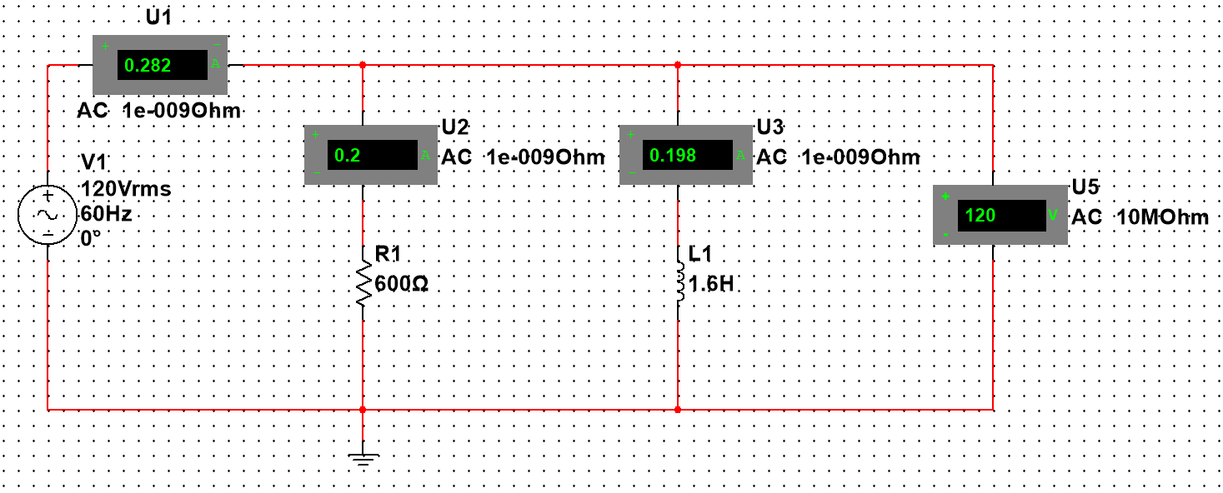
4. Using LabVolt equipment, build the parallel circuit shown and measure the total current, the current through and voltage across each circuit element (600Ω and 1.6H). Show that Kirchhoff’s current law holds.

 | Calculated |  | Measured
Circuit Element | Voltage | Current | Voltage | Current
Voltqge Source | 120<0V | 282<  -44.6 mA | 120 V | 300 mA
Resistor, 600Ω | 120<0V | 200<0 mA | 120 V | 200 mA
Inductor, 1.6H | 120<0V | 199<-90 mA | 120 V | 200 mA

.
5. For the series-parallel AC circuit shown below, compute the total impedance, the total current, the current through and voltage across each circuit element (8.8μF, 600Ω and 1.6H).

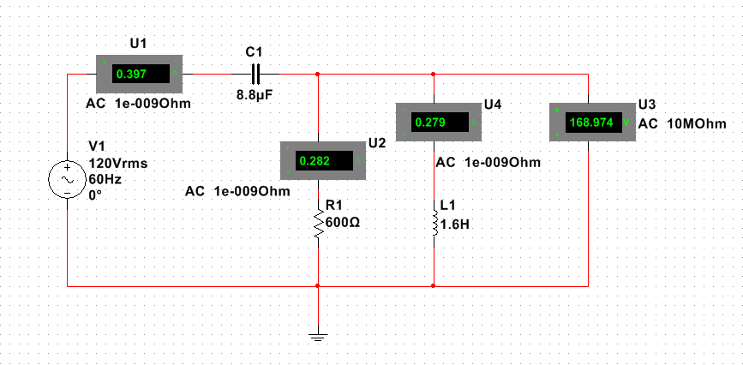

6. Using LabVolt equipment, build the series-parallel circuit shown and measure the total current, the current through and voltage across each circuit element (8.8μF, 600Ω and 1.6H).

 | Calculated |  | Measured
Circuit Element | Voltage | Current | Voltage | Current
Voltqge Source | 120<0 V | 399<0.19 mA | 120V | 420mA
Capacitor, 8.8μF | 120<  -89.8V | 399<0.19 mA | 127V | 420mA
Resistor, 600Ω | 170<45.3V | 283<45.3 mA | 165V | 280mA
Inductor, 1.6H | 170<45.3V | 282<  -44.7 mA | 165V | 300mA

(20%)Questions:

- Referring to the series circuit, what particular series circuit characteristics did you observe?

Current is the same throughout, voltages across inductor and resistor equal the source

- Referring to the parallel circuit, what particular parallel circuit characteristics did you observe?

Voltage is the same throughout, current across resistor and inductor add up to the total current

- When comparing the parallel circuit and the series-parallel circuit, why did the current increase to 400mA when the capacitor was added?

The capacitors negative impedance cancels out the inductors

